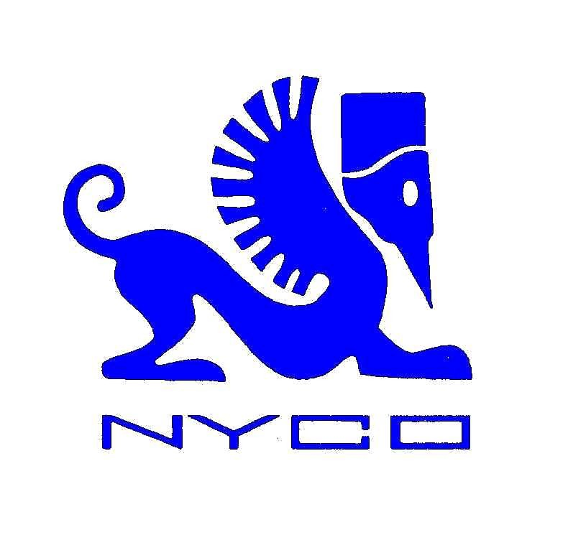 NYCO - Synthetic Lubricants
PRESENTATION
NYCO is an independent company which specialises in the development, manufacturing and sales of civil and military lubricants as well as esters and lubricants for automotive and industrial applications.
Our range of aviation and military lubricants include :
- lubricating oils for gas turbines
- hydraulic fluids
- greases
- specialities

These lubricants are manufactured in compliance with U.S., British, Russian and French specifications. At NYCO, we manufacture our own synthetic esters for captive use as well as for further sale to petroleum companies and independent blenders for automotive and industrial applications.
Ester and finished products are manufactured in Nyco’s fully owned plant located in Tournai, Belgium.

HEAD OFFICE : NYCO S.A. Tel : + 33 (0) 145615000
66, av. des Champs-Elysées Fax : + 33 (0) 145615013
BP 414 E-mail : info@nyco.fr
75366 PARIS Cedex 8
FRANCE

MILITARY LUBRICANTS

At NYCO, our lubricants for military applications include mineral oil-based products, as well as synthetic products mainly based on synthetic esters.
The high thermal stability, low volatility and low pour point of the synthetic basestocks (PAO or ester) used in Nyco’s formulations are particularly well designed for the lubrication of equipment operating at extremely high temperatures, extremely low temperatures, or both.
Our unique range of military products encompasses more than 160 different brands, used in various applications in all three armed forces: Army, Air Force and Navy.
NYCO is also the sole manufacturer of military lubricants able to offer a complete portfolio for US/European-made and Russian/Ukrainian-made equipment.
- Products to US and European military specifications
- Products to Russian specifications
CIVIL AVIATION LUBRICANTS
At NYCO, we feature a complete range of synthetic, semi-synthetic and mineral oil-based turbine oils, aviation greases, hydraulic fluids and protective compounds for civil aviation purposes.
These products are formulated and approved against the relevant military specifications and validated by major aerospace Original Equipment Manufacturers (Airbus, Boeing, Eurocopter, CFMl, IAE, Rolls-Royce, Pratt & Whitney…)
- American and European aircraft
- Russian and Ukrainian aircraft (1/2)

AUTOMOTIVE AND INDUSTRIAL PRODUCTS
At NYCO, our high level of expertise in synthetic military and civil aviation lubricants is the result of more than 40 years of experience.
We have used this expertise to develop and market synthetic esters (NYCOBASE), formulated lubricants (NYCOLUBE) and hydraulic fluids (HYDRAUNYCOIL) for the automotive and industrial sectors as well as speciality ester plasticizers for the polymer industry (NYCOFLEX).
We develop and market high performance synthetic fluids used in extreme operating conditions in which mineral-based fluids show weaknesses.
The environment is important at NYCO. We are very active in developing environment-friendly lubricants. We offer non-toxic, biodegradable esters as well as fully formulated lubricants.
- DEVELOPMENT :
- Highly specialized development laboratory.
- 40 years experience.
- Application laboratory
- Synthetic basestocks formulation know-how.
- Joint development projects (partnership).
- 5000 + esters database.
- Testing facilities.
- MANUFACTURING :
- High flexibility.
- Medium-and large-sized reactors.
- Online control laboratory.
- Customized esters.
- Toll processing.
- Blending and filling facilities.
- PRODUCTS :

Wide range of synthetic esters :
- Monoesters.
- Diesters.
- Neopolyol esters.
- Complex esters.
- Special esters.
Fully formulated lubricants :
- Air-cooled and water-cooled 2-stroke engine oils.
- Biodegradable and racing 4-stroke engine oils.
- Shock absorber oils.
- Biodegradable hydraulics fluids.
- Less flammable hydraulics fluids (HFDU type).
- Air compressor and refrigeration compressor oils.
- High temperature chain oils.
- Synthetic gear and bearing oils.

SALES / MARKETING / SUPPLY CHAIN:
- Sales of esters and fully formulated lubricants to oil companies and independent lubricant companies.
- Dedicated business team.
- Global sales network
- Efficient and optimised supply chain network worldwide
(2/2)

